Project Name | SMC
Report as of | 6- December-2018

Objective
ICU installed in the city buses will start implementing the PIS health related messages and messages selected by driver to the server. The document details the changes expected in the backend for supporting this.

PIS health
PIS health messages will reach the backend as serial message. So ICU handler have to process the messages. As per CM protocol, one message is a automatically triggered when it detects a problem with display (or when the problem solves). The other method is to query the status from backend and device will respond with current status. So the message handling in the backend, will have to be done by the ICU handler. To periodically sent query to all city vehicle we have to update an existing service. There is already a service that periodically sends alive request/ route question etc to all city buses. The same service needs to send the new query to all city buses. The message will be automatically handled by FCS.

To manage the PIS health status of City bus we have to include few more tables in our DB also.

DB changes
We should have an inventory table named CityBusPISMapping. The table contents are
No | Column name | Purpose
1 | VehicleID | VehicleID, reference to vehicle table.
3 | FrontPIS_SeqNo | Sequence number of Front PIS in the vehicle
4 | RearPIS_SeqNo | Sequence number of Rear PIS in the vehicle.
5 | InnerPIS_SeqNo | Sequence number of internal PIS in the vehicle

This table is updated by ICU handler. See ICU handler changes.

ICU handler changes
ICU handler have to handle two messages. One is the sign information message and second is the DTC code message.

Handling sign information message.
The message format is
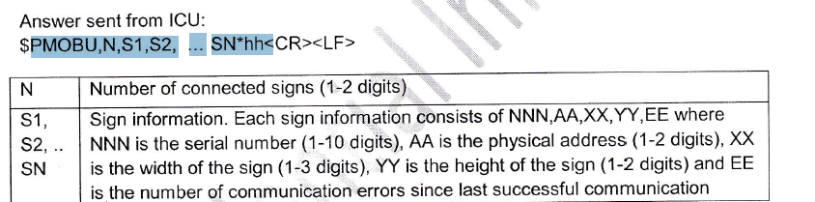

So if the message starts with $PMOBU then ICUHandler can start handling sign information message. In the message the N field determines how many sign information are present in the message. So if value is 1 then info about only one sign will be present. The sign info (S1,S2 etc) are composed of NNN,AA,XX,YY,EE format.(Note EE will not be present in the message as per CM. Reason is given in below section).
As per CM, only the working sign status will be present in the answer. For working sign EE will be zero and since it is zero they will not send EE part. Hence we can assume that the syntax of sign status is NNN,AA,XX,YY (no EE).

Where NNN is the sequence number of the sign. First we have to identify what type of sign is it (front/rear/inner). For this take the AA field.
As per CM the value of AA is mapped as
06 – Front
07 – Side (we are not using it).
11-- Rear
03 -- Internal Sign

Based on the type of the signstatus, set the corresponding signstatus column in real time vehicle parameters table as working. The missing signs can be set as not working in real time vehicle parameters table.

Apart from determining the health of the display ICU handler also needs to update the CityBusPISMapping table. Module in the startup needs to load the table contents to the memory. When a new message is received it have to check in the memory whether for this vehicle and this type of sign, the serial number is same or not. If there is a difference (or the info for the vehicle or the sign info is not available in table) then update the database table and update the internal data. In this way we will always keep the PIS mapping live in our database. This table contents are used in handling the DTC information.

For example: Lets say we received data like this from device $PMOBD,2,210140554,3,16,112,2543656432,11,16,96,34*69

The message shows that two signs are working(N = 2). The two sign status fields are (S1 and S2) 210140554,3,16,112 and 2543656432,11,16,96 respectively. The first sign is the internal sign (since AA is 3) and the second sign is rear display (AA is 11). Hence ICU handler can set that for this vehicle rear display and internal display are working and front display is not working. (updates in RealTimeVehicleParamtes table – are we also keeping history?)

Now we need to cross check whether serial numbers are updated correctly in CityBusPISMapping table. Lets assume that for this vehicle no entry is available in that table (so no value for this vehicle in internal structure also ). So for this vehicle update that RearPIS_SeqNo is 2543656432 and InnerPIS_SeqNo is 210140554. We don’t know yet the serial number of front PIS, but we know that front is not working.

Handling DTC information message.
The message format is
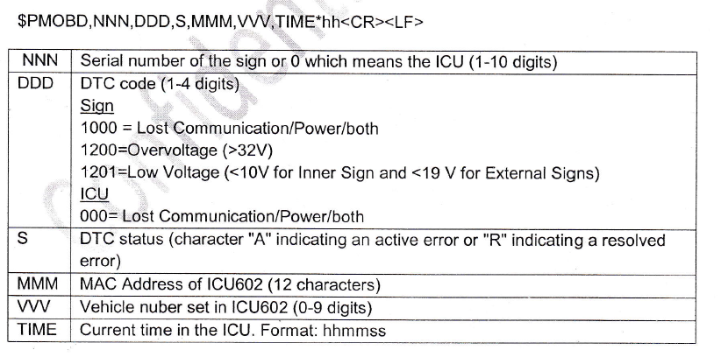

This message is send from the vehicle whenever ICU detects a problem/or a problem is solved for the connected signs or the ICU itself. We are interested only in processing the problems with the connected signs.
- If the NNN is zero, its about ICU so discard the message.
- If it is not zero, check with the internal memory where the contents of table CityBusPISMapping is kept to identify the type (front/rear/inner) of the sign. If this sequence number is not present
  - Then check whether sequence number of other two displays are present.Then we know that this is about the missing sign. Then insert the serial number of the missing sign in the CityBusPISMapping and identify the type of sign. Continue to step 3.
  - If sequence number of more than two sign status of the vehicle is missing, then we are not able to identify which sign status is reported now, so message processing can be skipped.
- If the type of sign is determined then check the DTC code (DDD) field and DTC status (S).
- If DDD is not 1000 or S field is not A or R then discard the message.

- If DDD is 1000 and S is A, then we can mark the signstatus ( in realtimevehicleparamters table we keep the health of PIS connected in bus) as down (0 I think). There are status column for front/rear and inner sign. Make sure that the right field is updated.
- If DDD is 1000 and S is R. Then ICU says that the sign is now in working state so mark the corresponding sign status as working.

Driver triggered messages
ICU will be supporting sending message to backend initiated by driver. Driver will be able to send info like- start/end trip, send panic messages, selected driver and conductor id. The message format is given below

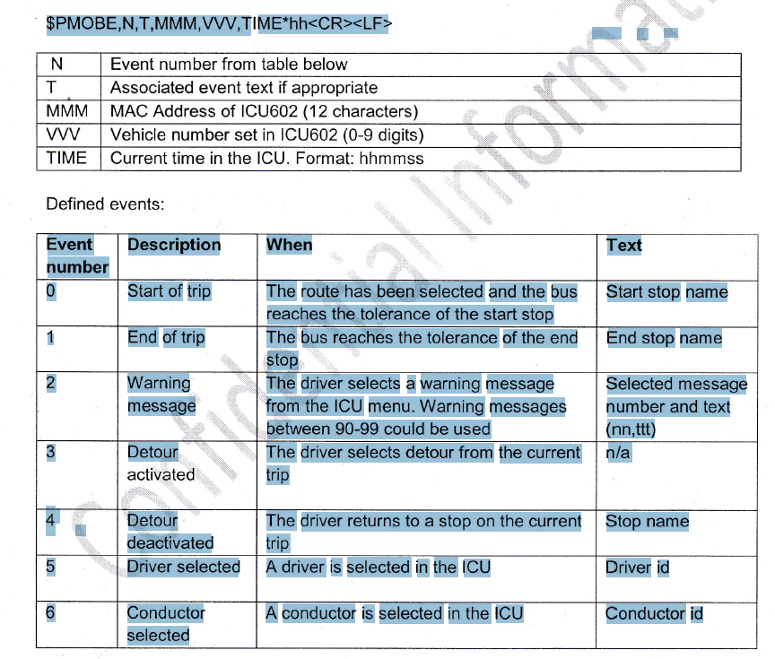

Changes required in modules
There is no change in the FCS, since all the serial messages are passed as such by FCS. ICU handler module will receive the message as serial message (RMQ) and the module have to process the message.

ICU handler changes

Module already checks what kind of serial message is received from the RMQ. If the string starts with $PMOBE then module can do the following checks
- The expected format is $PMOBE,N,T,MMM,VW,TI ME*hh
- Check the event by looking at the event number (N in the message). Based on the type of message detailed task to be done is given below

Trip start and Trip end
If the event is 0 or 1 then this is about start or end of the trip as selected by the driver. ICU handler have to insert these events in a new table. Lets create a new table with following columns
Table TripStartEndEvents
No | Column name | Purpose
1 | ID | Auto Incriment
2 | VehicleID | VehicleID, vehicle ID from which we received the message. The RMQ will have OBUID, so module have to find out the vehicle ID.
3 | eventID | trip start or trip end as received from the device. (0 or 1)
4 | StopName | Name of the stop received from the device. This will be present in the T field of the incoming message.
5 | EventTime | Time of the event. Time is available in the RMQ message

Panic Message
If event type is 2, then it is a panic message. The panic message will be available in the T field of the serial string. On receiving panic message; ICU handler have to create a panic message (this is usually created by FCS module) and send it to Rabbit MQ. The message exchange and the message type shall be configurable.
The panic message structure is given below

Field | Size | Data Type | Comment
MagicNumber | 4 | UINT32 | Header Magic Number. The value should be 3737837078
MessageType | 2 | UINT16 | Header Message Type should be 1
DeviceID | 8 | UINT64 | Device ID (OBUID)
MessageId | 4 | UINT32 | Message ID. Default set to 0
DataType | 1 | BYTE | Data type ID. It should be 7 always
Panic MessageLength | 2 | UINT16 | Length of the panic message
PanicMessage | n | string | Panic message received from the device. This is the value present in the T field..

Driver selected or conductor selected
If the event is 5 or 6 then it is the event of driver selected in the vehicle or conductor selected in the bus. Whether we should authenticate the driver/conductor is not clear now. So apart from the authentication part do carry out all the things that are now implemented for Primeedge device. I guess we are storing driver name in realtimevehicle parameter table, and an entry is made in driverlogin history also. Do the same thing here as well.

For conductor, just add conductor id in realtimevehicle parameter table. We will later decide whether we need to add history for conductor.

UI changes
- The data stored in the new table TripStartEndEvents have to be made visible to trip analysis screen.
- The current driver and conductor id selected for each city vehicle shall be made available in the new page. Page similar to Primedge ICU status but only for city bus. We already have a vehicle ICU status page and that’s full. That’s why a new page similar to Primeedge ICU needs this one.

